British Cemetery at Baithkol, Karwar near Mangalore, India

There are two Cemeteries located within the compound of the Detachment Project Seabird at Baithkol. The Catholic cemetery is under the Parish Priest of the High Church, Karwar and is presently under use. There is a possibility that any old graves would have been removed. The other cemetery, the British Cemetery is maintained by the Parish Priest of the Down Church, Karwar. This cemetery is in fairly good condition and the under growth is being periodically cleared. There are 24 graves, and some of the headstones are broken and un-numbered. Many a 'forgotten and unknown soldier' lies here. (Comparing these graves with the graves of the Agram Cemetery, Bangalore, the shapes of the monuments are different, and one can find crosses on the stones at Baithkol which are missing in Agram. The Agram Cemetery is another project that Admiral O.S. Dawson is championing to restore, this cemetery started around 1809.) Since the cemeteries are within the limits of the Project Seabird, visits are restricted with special permission from the Defense Authorities. However, with the courtesy of Admiral O.S. Dawson I.N.(Retd), PVSM, AVSM, Former Chief of the Naval Staff, and Former High Commissioner for India in New Zealand, through his official sources, the following information is being made available.

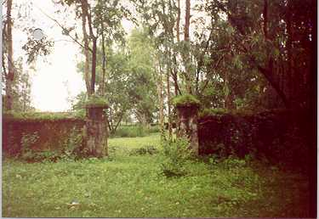

Layout of British Cemetery at Baithkol, Plan View
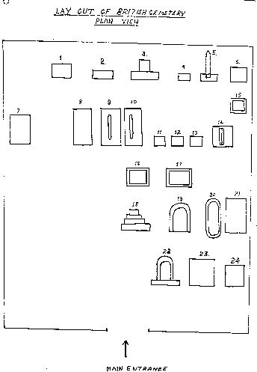

Details of Inscriptions of Headstones of the British Cemetery at Baithkol
Sl | Name | Date of Death | Place of Death | Details
1 | GEORGE STLIBBS | 29 Jan 1865
2 | Not written
3 | EDWARD JONES | 29 Oct 1895.
4 | Not Written
5 | HELLEN JANE | 06 Jun 1872
6 | WILLIAM EARNEST FALLSILNNY | Not Readable
7 | THOMAS JONES | 20 Apr 1863
8 | HENRY JOHN RAWLE | 25 Mar 1872
9 | EMMA JULIA LOUIS | 12 Sep 1872
10 | HENRY INGLE | 12 Jul 1898 |  | F/o --, Karwar
11 | Not Written
12 | Not Written
13 | Not Written
14 | ELIZABETH DE'CRUZ | 22 Oct 1875
15 | ERNEST HASENVANDEL | 23 Nov 77 (1877)
16 | Not Written
17 | Not Written
18 | CAPT. ECG MADOOCK IMS | 01 May 1908 | Karwar
19 | ROBERT NIBLOCK | 07 Nov 1890 |  | Royal Artillery
20 | EVANGELINE MARY BELL | 17 July 1941
21 | THOMAS REID DAVYES BELLCIE | 24 Jun 1948
22 | GEORGE TRAIL | 06 Dec 1869 Aged 32 Yrs & 8 Months |  | (Late Engineer) In-Charge of Nicol & Co’s Works. Karwar
23 | LOISA | 02 Aug 1867 |  | W/0 HORATIO RHODES NELSON (Eng Bombay)
24 | Not Written

